Name : Mriganka Patra
Emp id: 2415820
Email : mriganka.patra@cognizant.com

Day 10

Assignment 2:
Salesforce – Service Cloud and Additional Platform Features
Objective:
Explore Service Cloud capabilities and additional Salesforce platform tool lke Chatter, Activities, App Launcher, and App Exchange
Tasks:
- Set up Service Cloud and create a simple Case Management system:
- Create Case Record Type and configure assignment rules
- Automate Case escalation based on Priority
- Use Chatter to:
- Collaborate on Case and an Opportunity
- Mention users and follow records
- Track Activities on a Lead and a Case:
- Log calls, emails and meetings
- Use App Launcher to navigate between Sales, Service, and Custom Apps
- Visit App Exchange and install a free app(or document how to find and evaluate apps).

Deliverables:
- Case setups and automation details
- Chatter activity examples
- Logged activities and App Launcher exploration
- Summary on AppExchange app evaluation or installation

Task 1: Set up Service Cloud and create a simple Case Management system:
- Create Case Record Type and configure assignment rules
- Automate Case escalation based on Priority

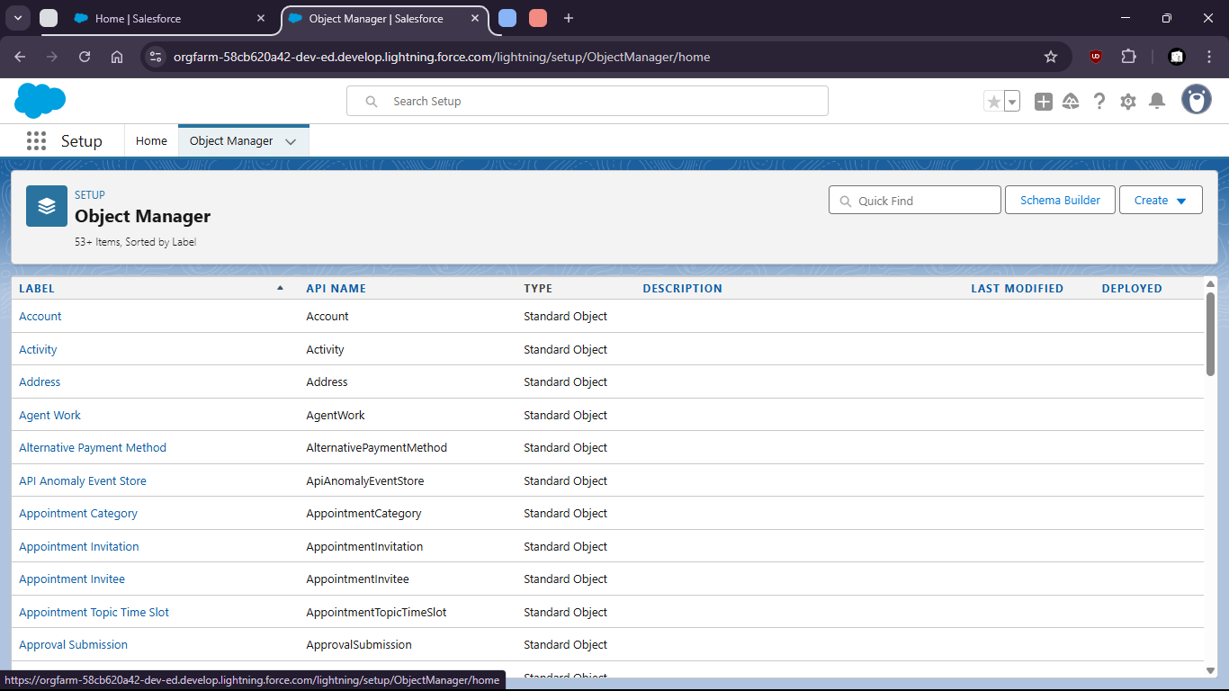

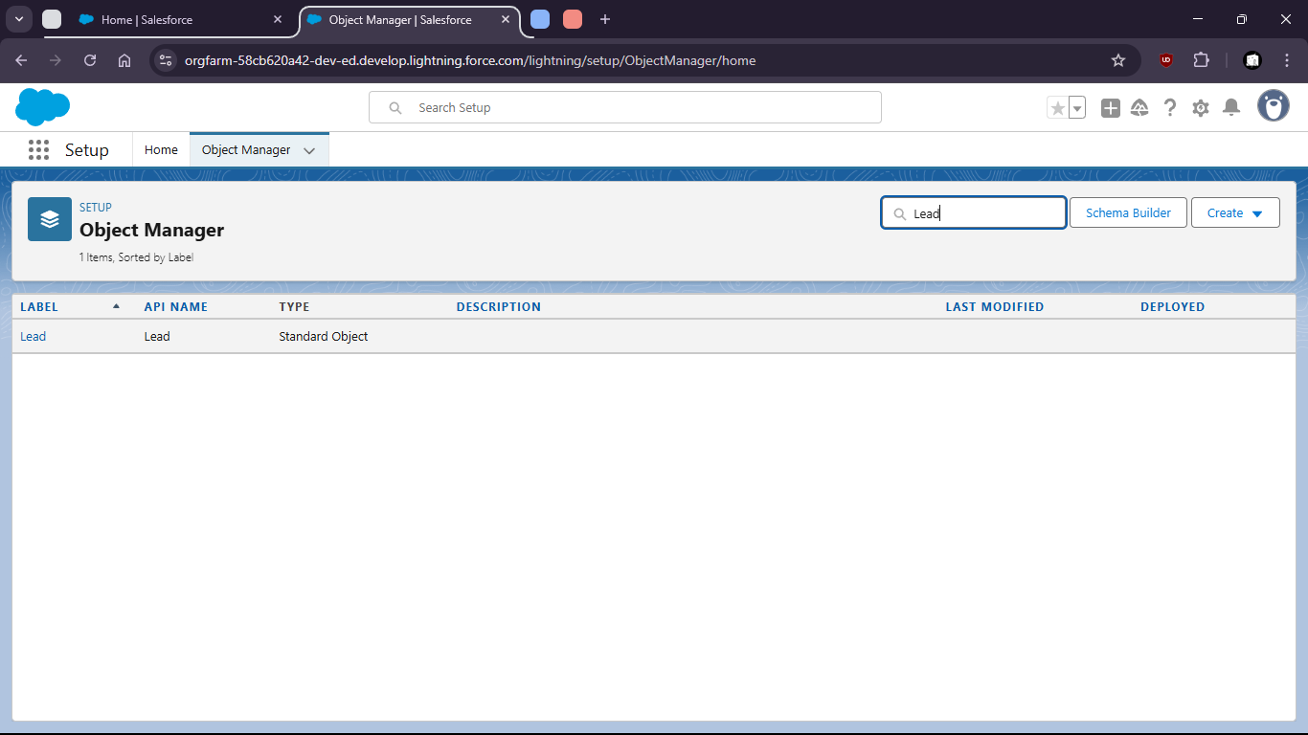

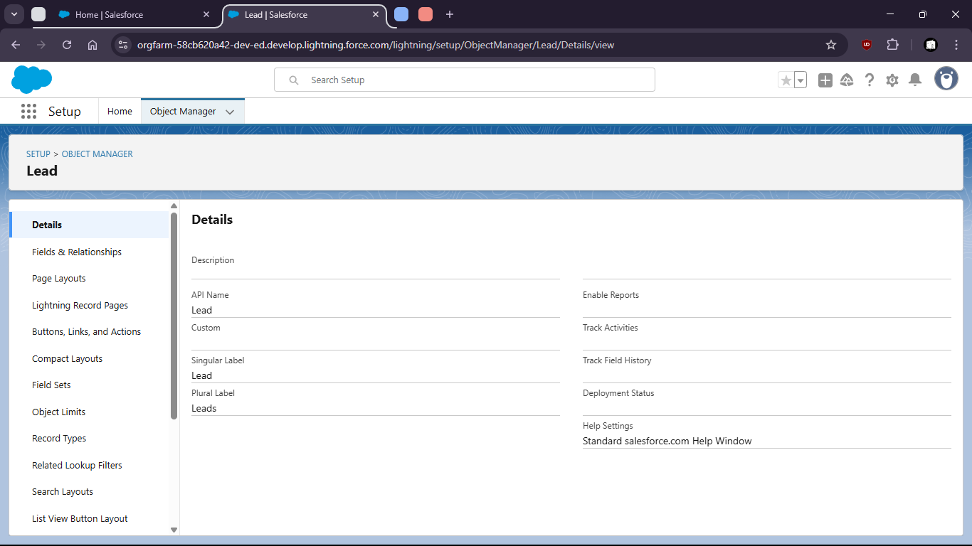

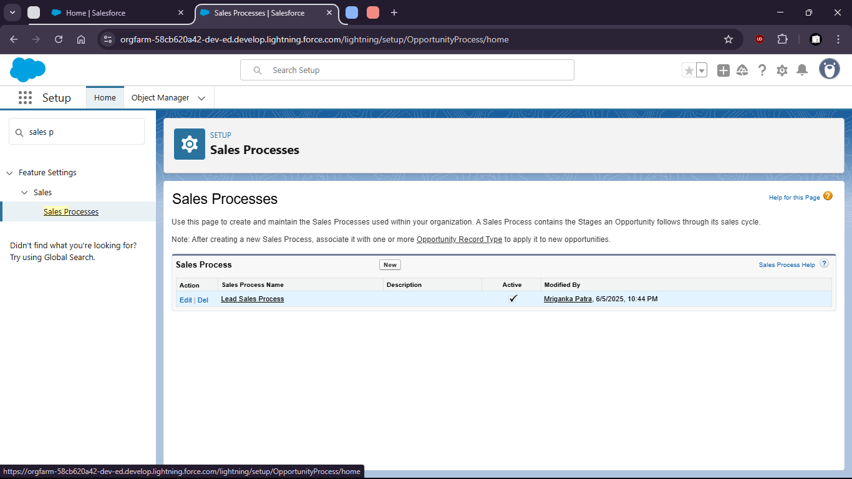

Automate case escalation based on Priority

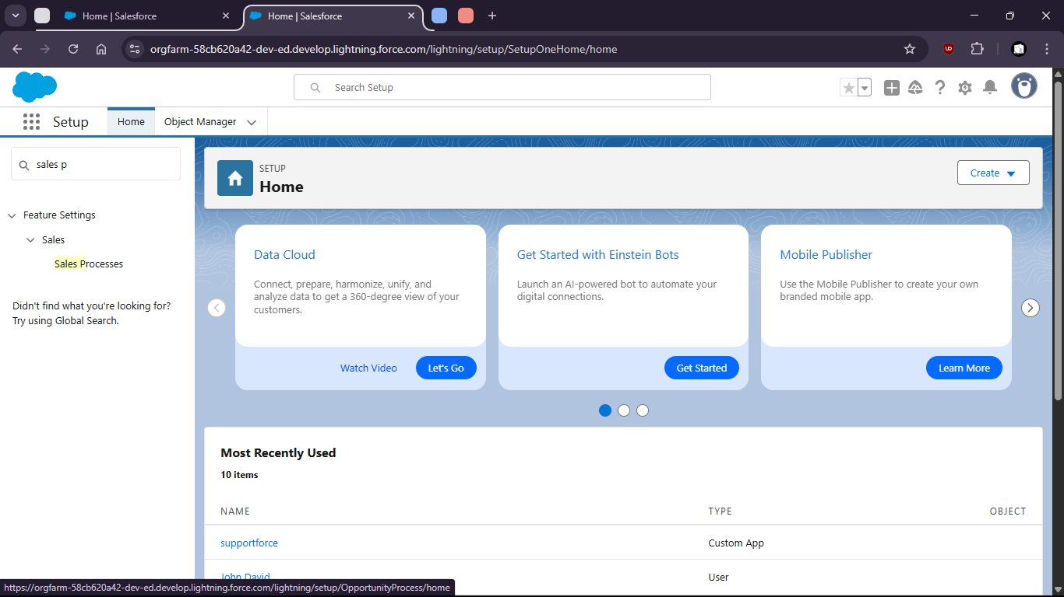

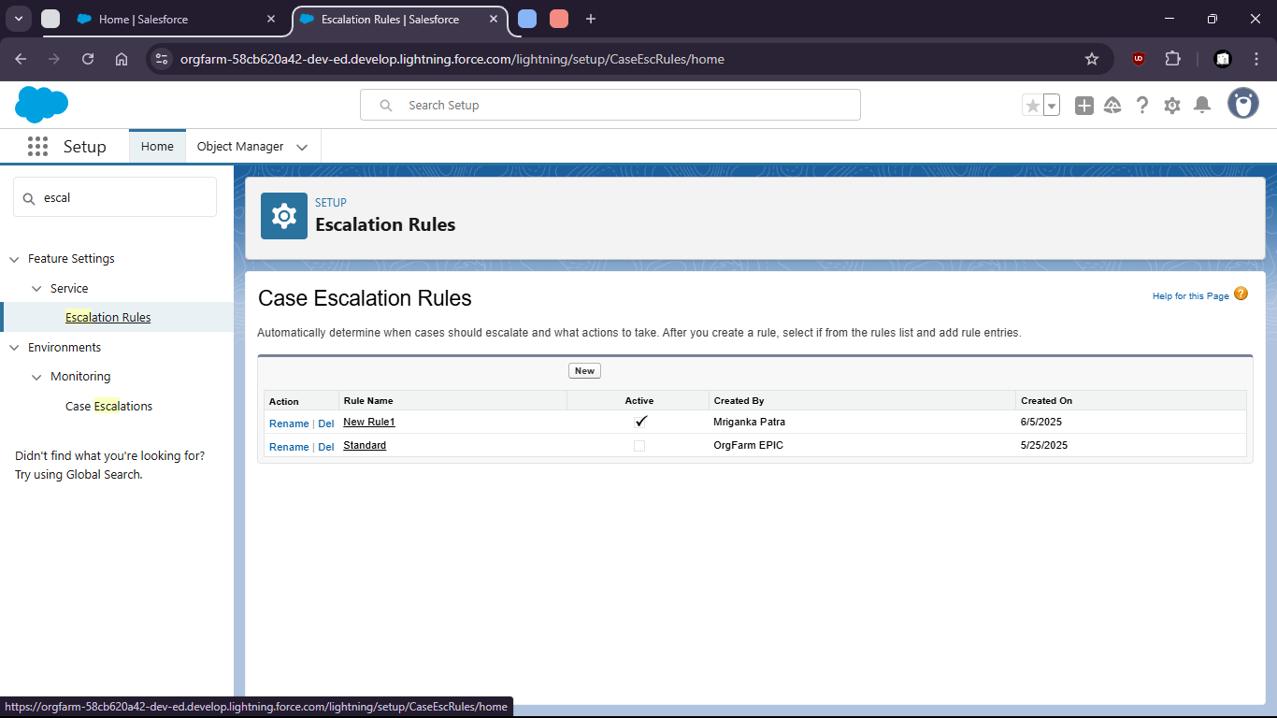

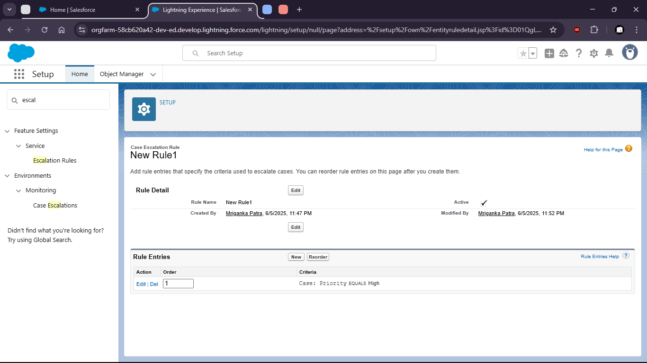

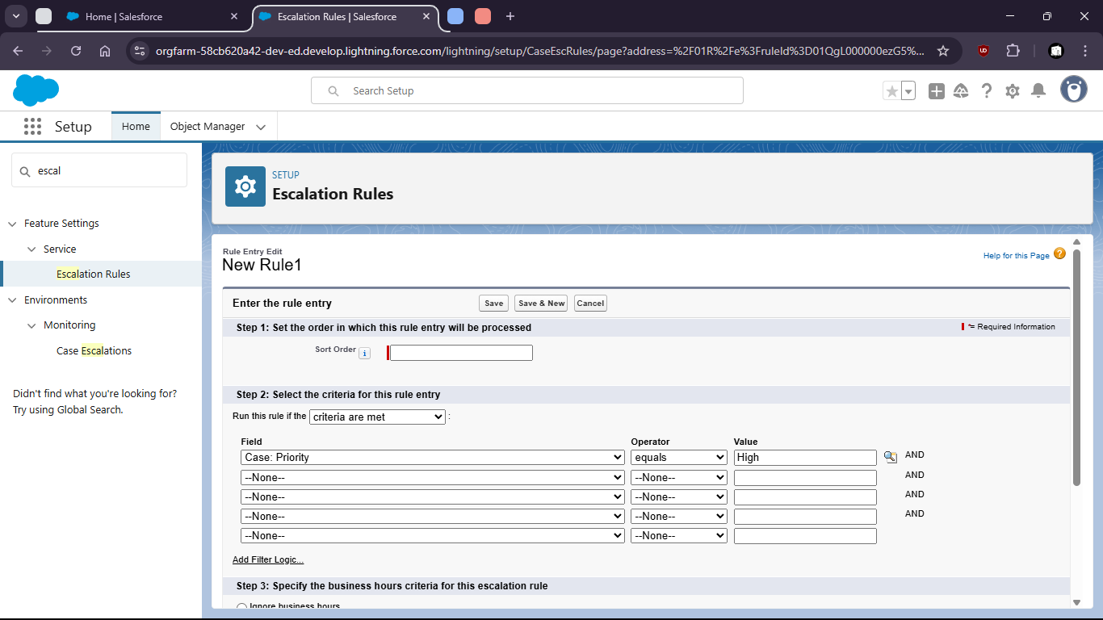

Task 2: Use Chatter to:
- Collaborate on Case and an Opportunity
- Mention users and follow records

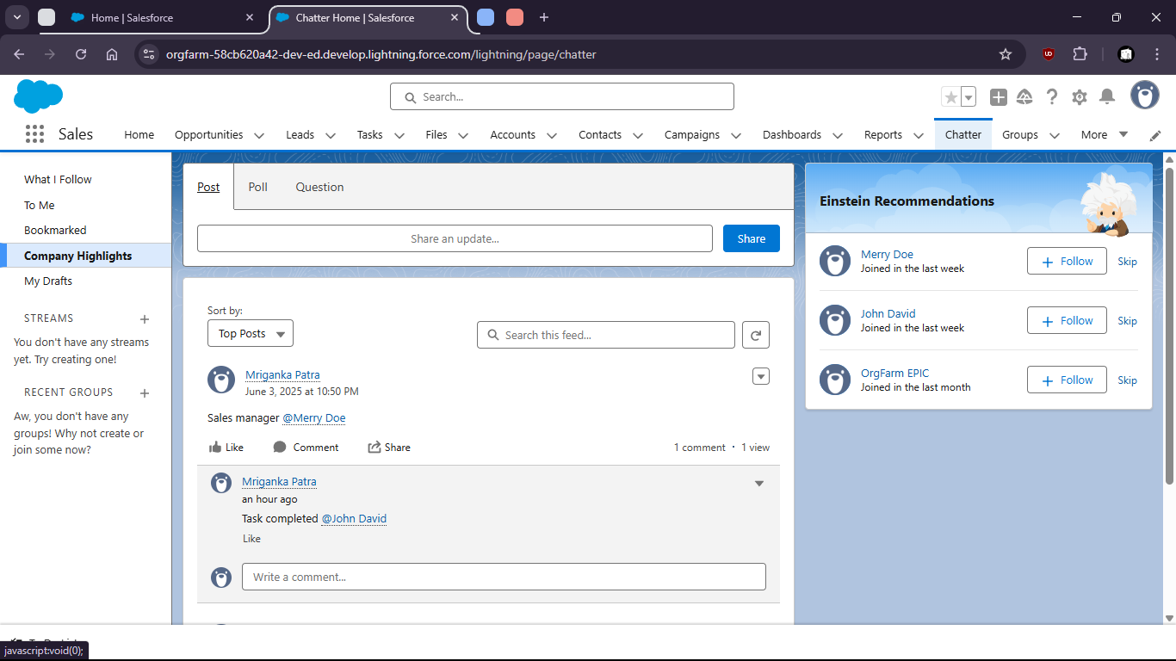
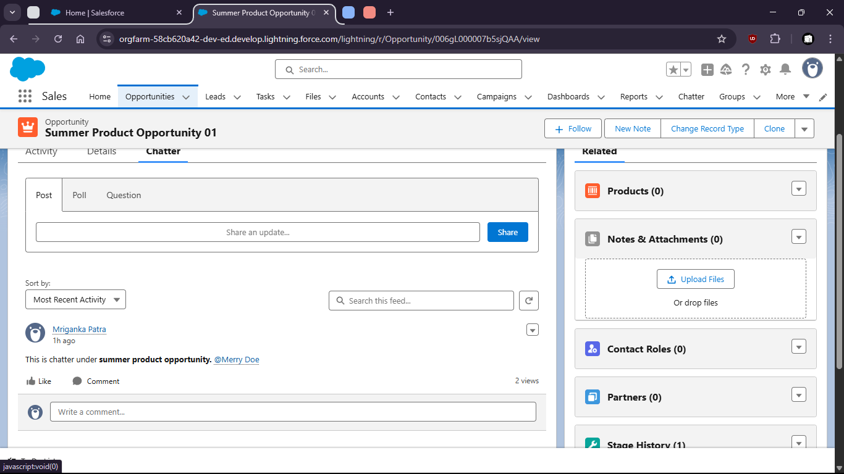

Task 3:
- Track Activities on a Lead and a Case:
- Log calls, emails and meetings

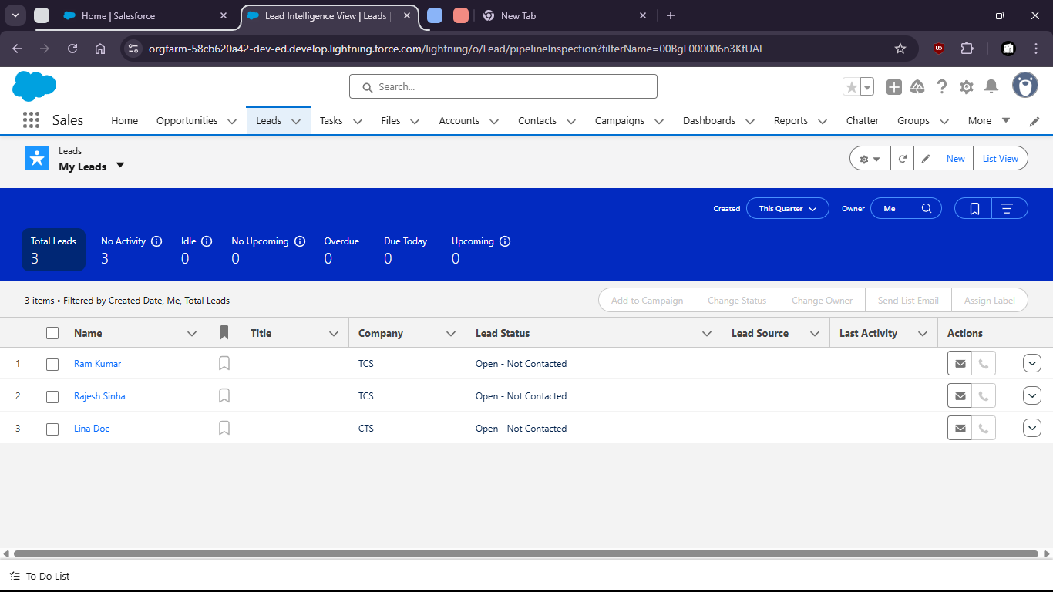
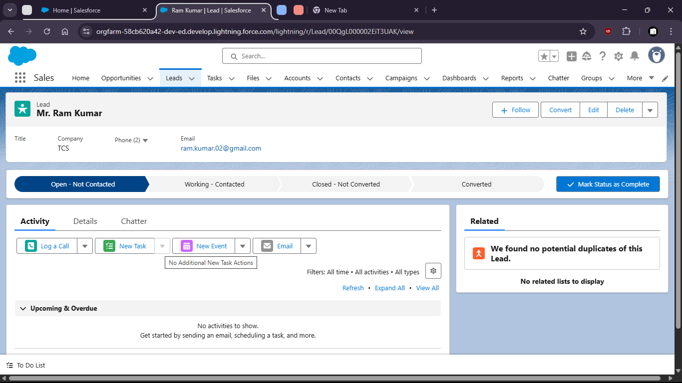

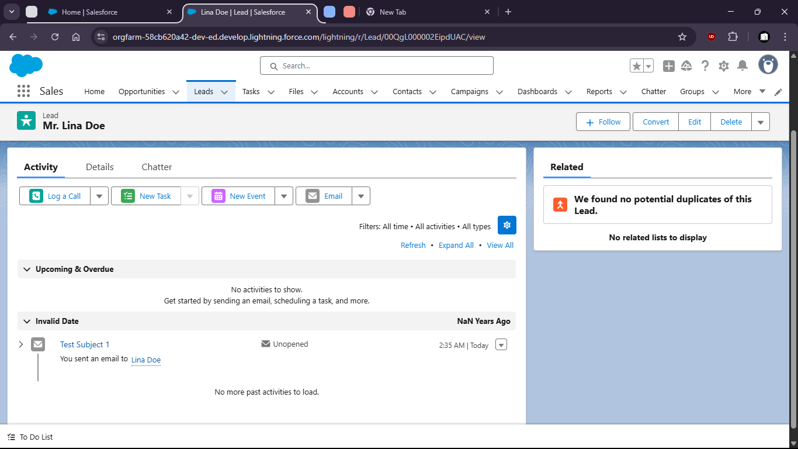
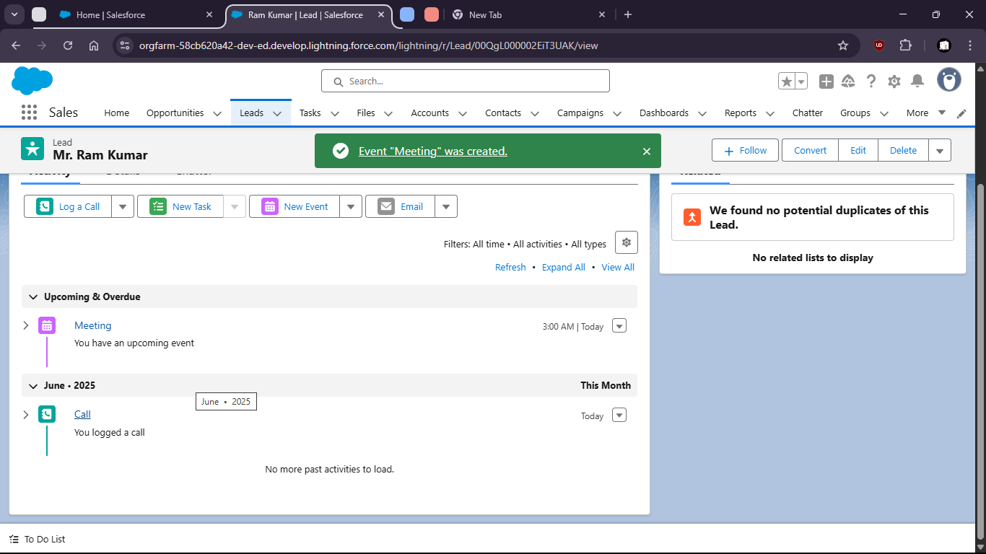

Task 4

Use App Launcher to navigate between Sales, Service, and Custom AppsSalses App

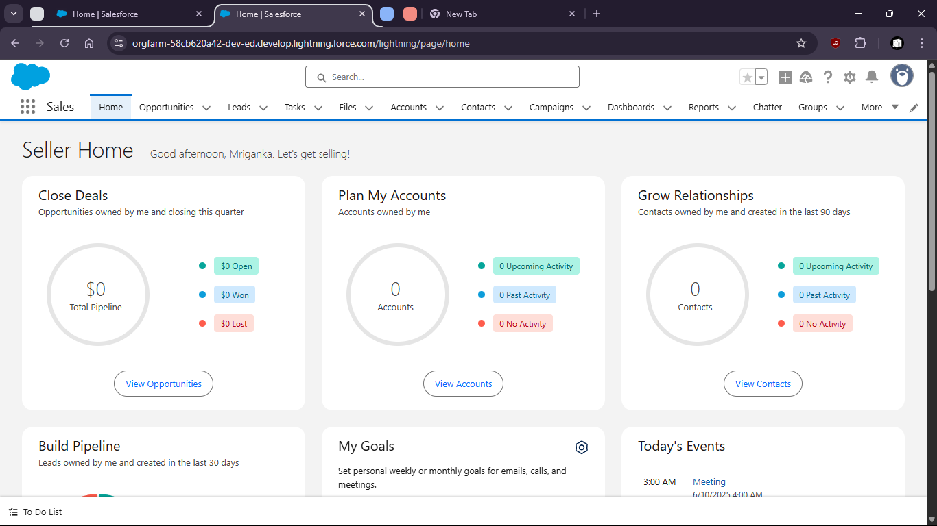

Service App

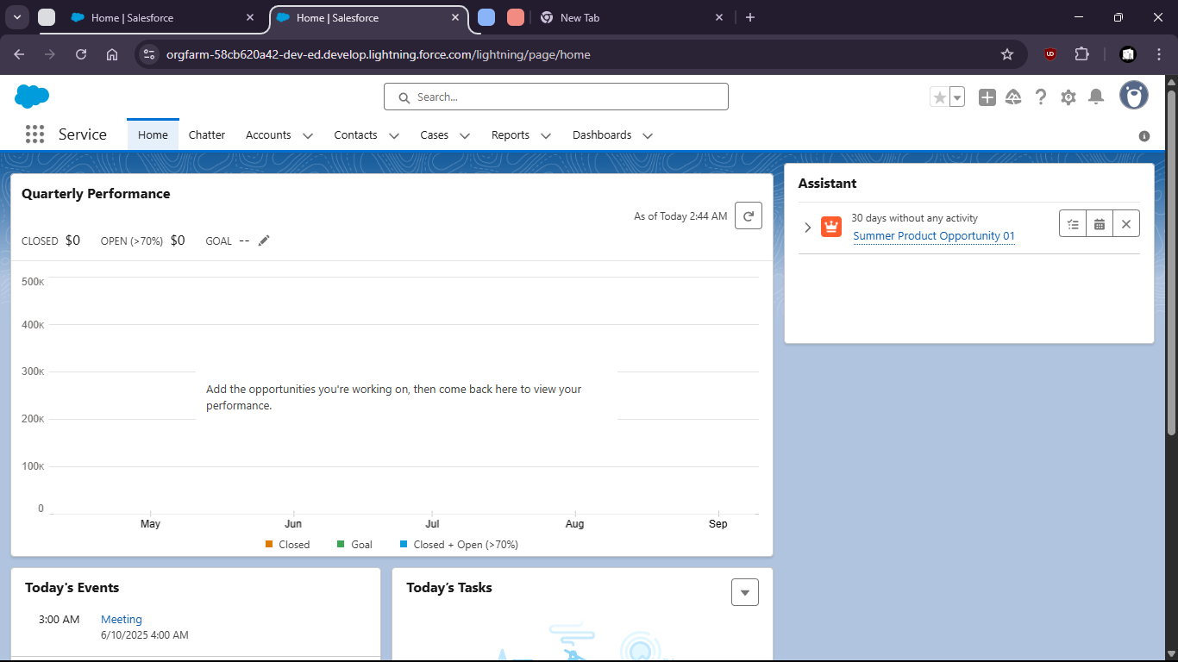

Custom Application : Sales Task (with custom object fields)

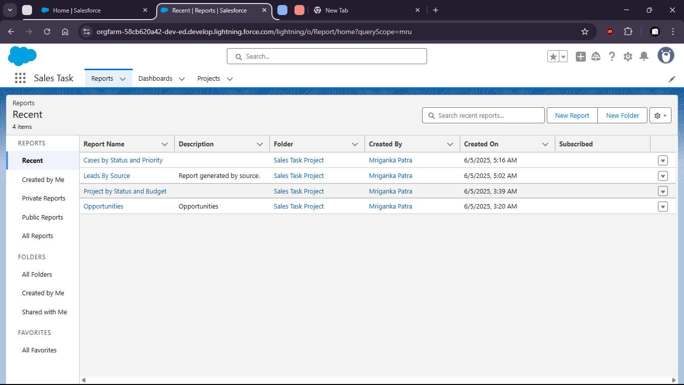

5: Visit App Exchange and install a free app (or document how to find and evaluate apps).

